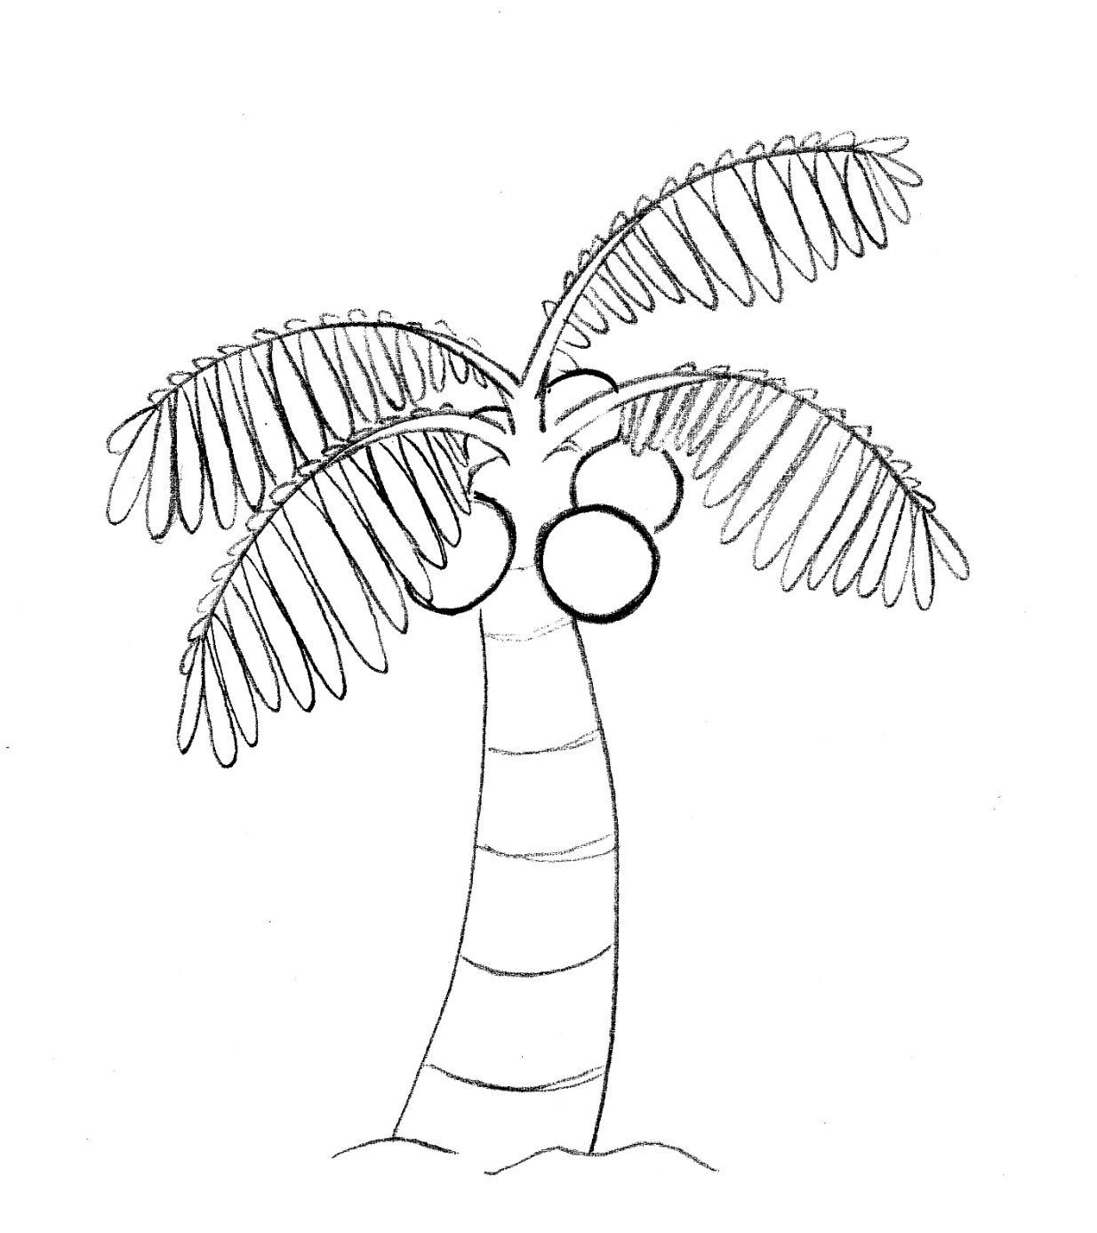
The Coconut tree is called the “Tree of Life”
it provides medicine, nutrition, fuel and shelter.
Here are some of its amazing uses:
Flowers & Inflorescence: Apparel, vinegar
Fruit & Seed: Coconut milk, oil, sugar
Husk: Brushes, rope
Leaves: Baskets, mats, fans, hats, roofs
Roots: Medicine, beverages
Shells: Utensils, musical instruments, charcoal for cooking
Spathe & Guinit: Headgear, sandals
Trunk: Houses, furniture

Illustration by Chloe Ricks

