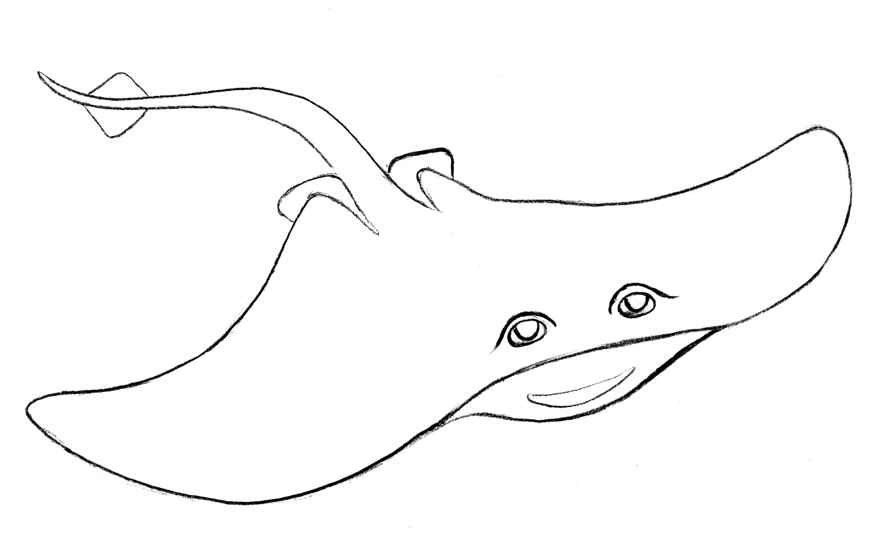

Manta rays are some of the ocean’s gentle giants are known for their curiosity.
These amazing animals are related to sharks and other rays
and have a skeleton made of cartilage, instead of bone.
The manta rays are protected under the Convention on International Trade in Endangered Species
of Wild Fauna and Flora (CITES) which prevents any trade or harvest of the species
that may be detrimental to the survival of the species in the wild.

Illustration by Chloe Ricks

